NOW PUBLISHED
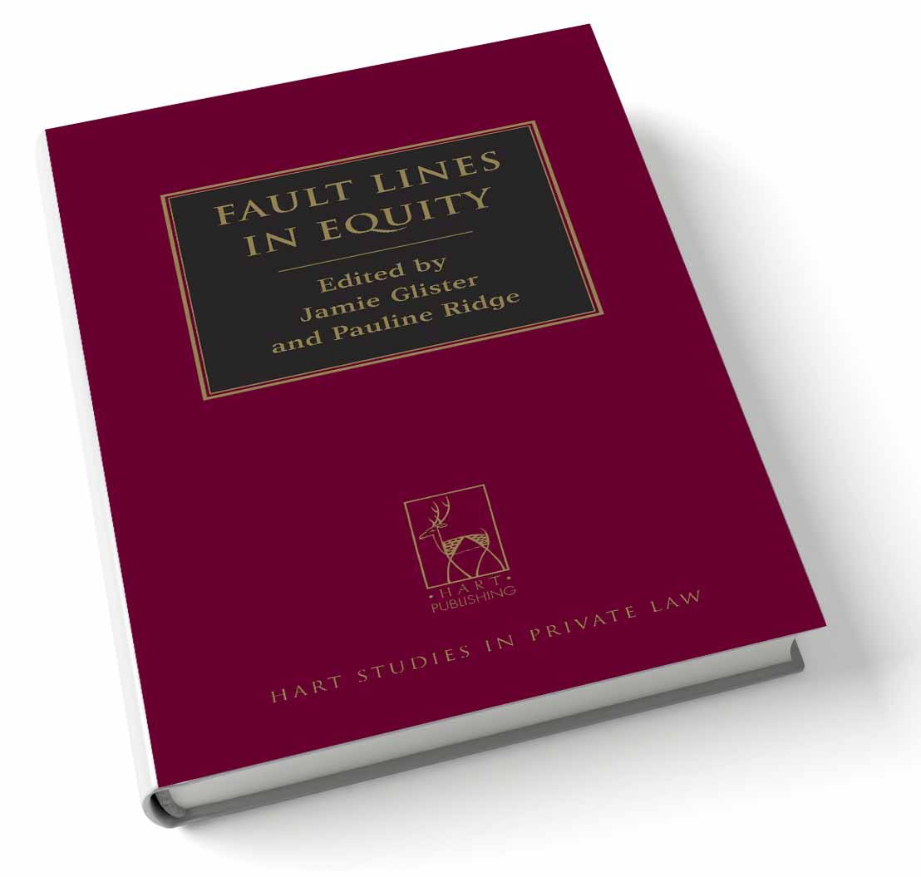
Fault Lines in Equity
Edited by Jamie Glister and Pauline Ridge

Equity, the body of law developed in the English Court of Chancery, has a long and distinguished history. In the twenty-first century it continues to be an important regulator of both commercial and personal dealings, as well as informing statutory regulation. Although much equitable doctrine is settled, there remain some intractable problems that bedevil lawyers across jurisdictions.

The essays in this collection employ new historical, comparative and theoretical perspectives to cast light on these fault lines in equitable doctrine and methodology. Leading scholars and practitioners from England, Australia and New Zealand examine such contentious topics as personal and proprietary liability for breaches of equitable duties (including fiduciary duties), the creation of non-express trusts, equitable rights in insolvency, the fiduciary 'self dealing' rule, clogs on the equity of redemption, the distribution of assets on family breakdown, and the suitability of unjust enrichment analysis. The authors address specific doctrinal questions as well as the 'meta' issues of organisation and methodology, and their findings will be of value to academics and practitioners alike.

TABLE OF CONTENTS
1. Unjust Enrichment versus Equitable Principles in England and Australia JOACHIM DIETRICH
2. Subrogation, Equity and Unjust Enrichment MARK LEEMING
3. Clogs on the Equity of Redemption: A Story of Changing Equitable Intervention FIONA BURNS
4. Assignment of Future Property and Preferences JOSHUA GETZLER
5. The Fiduciary ‘Self Dealing’ Rule JAMES EDELMAN
6. Participatory Liability for Breach of Trust or Fiduciary Duty PAULINE RIDGE
7. Equitable Compensation JAMIE GLISTER
8. Trusts and Knowledge: Lessons from Australia BEN McFARLANE
9. The Limits of Equity in Disputes over Family Assets MATTHEW HARDING
10. Constructive Trusts: Understanding Remedialism MICHAEL BRYAN
11. Thoughts on Equity in New Zealand and New South Wales ANDREW BUTLER and TIM MILLER

Jamie Glister is a Senior Lecturer at the University of Sydney.
Pauline Ridge is an Associate Professor at the Australian National University.

May 2012 300pp Hbk 9781849462198
£65 / €84.50 / US$130 / CDN$130
Discount rate to members of the RDG: £52 / €68 / US$104 / CDN$104
Hart Studies in Private Law series

As a member of the Restitution Discussion Group listserv Hart Publishing is delighted to offer you
20% discount.

Order Online
If you would like to order this title you can do so through the Hart Publishing website (links below)

UK, EU AND ROW ORDERS: http://www.hartpub.co.uk/books/details.asp?isbn=9781849462198

USA ORDERS: http://www.hartpublishingusa.com/books/details.asp?isbn=9781849462198

To receive the discount please mention ref: ‘RDG’ in the special instructions field. Please note that the discount will not be shown on your order but will be applied when your order is processed.

Alternatively, please complete and return the PDF flyer that can be downloaded through the following link and return to Hart Publishing: http://www.hartpub.co.uk/Glister_Ridge.pdf

If you have any queries please contact Hart Publishing.
Hart Publishing Ltd, 16C Worcester Place, Oxford, OX1 2JW, UK
Tel No: 01865 517530; Fax No: 01865 510710; Email: mail@hartpub.co.uk; Website: www.hartpub.co.uk
Hart Publishing Ltd. is registered in England No. 3307205

